A room in the morning, with a dining consists of 2 chairs and a table. A closed window with a

long flower

curtain

building behind a transparent window

cat

books

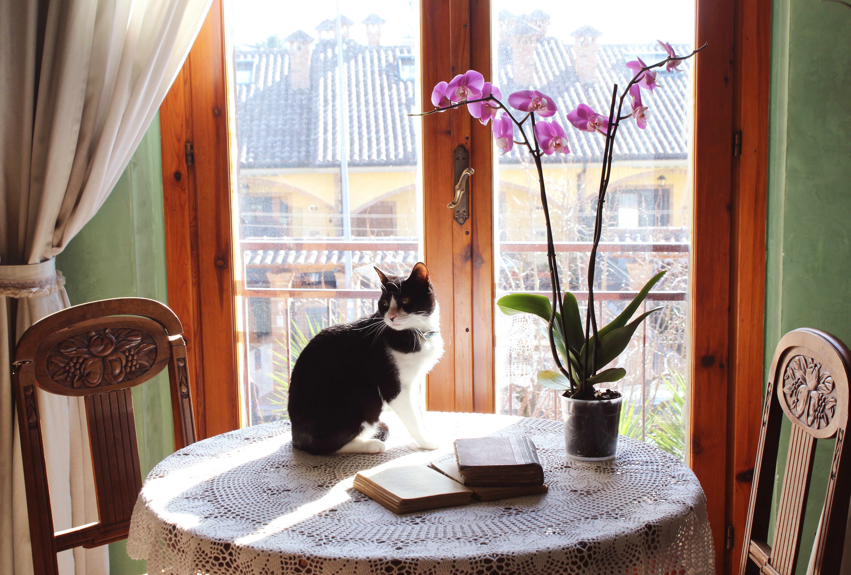

building view outside. The cat sit relaxed, at some point will jump from the table.